**%TYPE** : variable_name table_name.column_name%type; (dynamic)

Then we don’t get data type compatibility errors at any case.

**%ROWTYPE** : declaring as one record/row in table.

Drawbacks :

--if we want to display all values from record%rowtype variable.u nnecessarily memort space is reserved and its drawback.

-- if we want values from multiple tables. Means some values from table 1 and some values from table 2 and some values from table 3 then % rowtype variable not useful.

And there is no data type like that given by oracle.

**USER DEFINED RECORD TYPE :** TYPE <type_name> IS RECORD

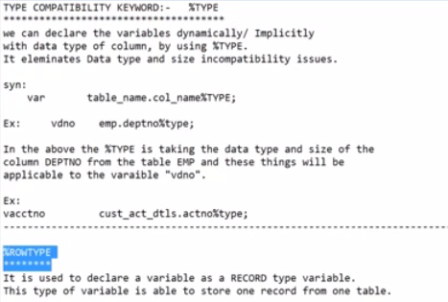

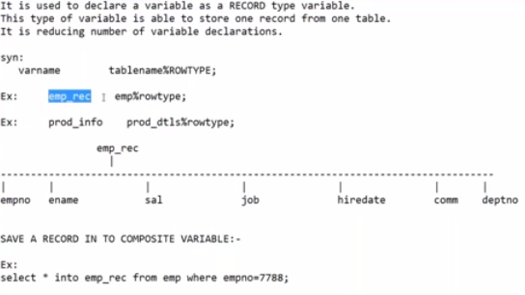

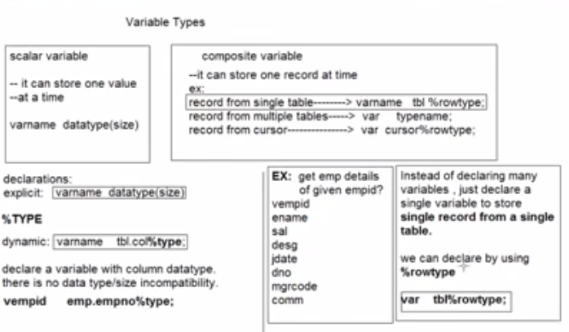

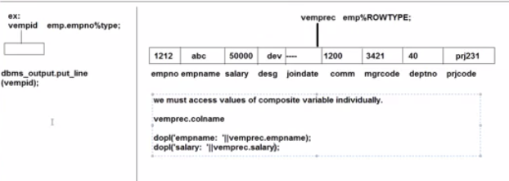

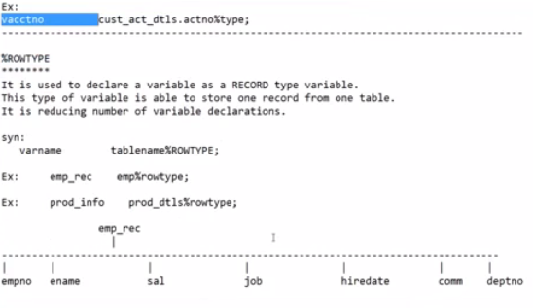

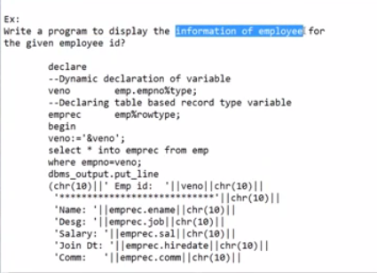

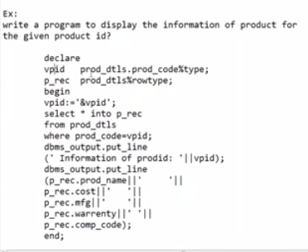

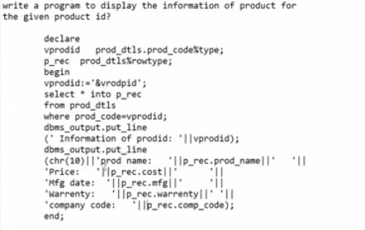

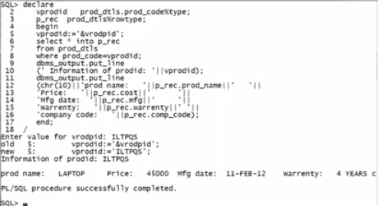

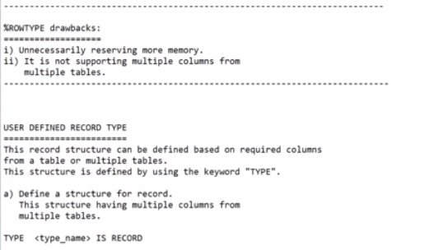

Drawbacks :

--if we want to display all values from record%rowtype variable.u nnecessarily memort space is reserved and its drawback.

-- if we want values from multiple tables. Means some values from table 1 and some values from table 2 and some values from table 3 then % rowtype variable not useful.

And there is no data type like that given by oracle.

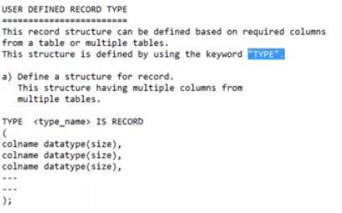

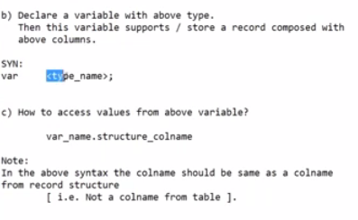

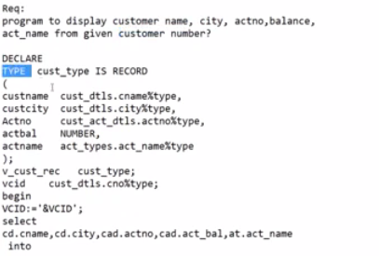

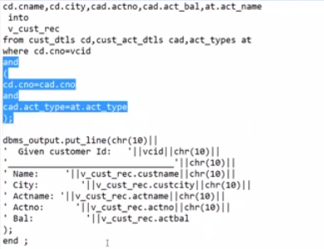

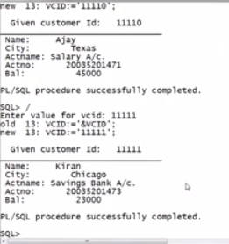

SQL> --write a program to display information of employee from the given employee id.

SQL> desc emp;

Name Null? Type

----------------------------------------------------------------------------------------------------------------------------------------------------------------------------------------------------------------------------------------- -------- ------------------------------------------------------------------------------------------------------------------------------------------------------------

EMPNO NOT NULL NUMBER(4)

ENAME VARCHAR2(10)

JOB VARCHAR2(9)

MGR NUMBER(4)

HIREDATE DATE

SAL NUMBER(7,2)

COMM NUMBER(7,2)

DEPTNO NUMBER(2)

SQL> set pagesize 150;

SQL> desc emp;

Name Null? Type

----------------------------------------------------------------------------------------------------------------------------------------------------------------------------------------------------------------------------------------- -------- ------------------------------------------------------------------------------------------------------------------------------------------------------------

EMPNO NOT NULL NUMBER(4)

ENAME VARCHAR2(10)

JOB VARCHAR2(9)

MGR NUMBER(4)

HIREDATE DATE

SAL NUMBER(7,2)

COMM NUMBER(7,2)

DEPTNO NUMBER(2)

SQL> set pagesize 550;

SQL> desc emp;

Name Null? Type

----------------------------------------------------------------------------------------------------------------------------------------------------------------------------------------------------------------------------------------- -------- ------------------------------------------------------------------------------------------------------------------------------------------------------------

EMPNO NOT NULL NUMBER(4)

ENAME VARCHAR2(10)

JOB VARCHAR2(9)

MGR NUMBER(4)

HIREDATE DATE

SAL NUMBER(7,2)

COMM NUMBER(7,2)

DEPTNO NUMBER(2)

SQL> --write a program to display information of employee from the given employee id.

SQL> declare

2 vempno emp.empno%type;

3 vemprec emp%rowtype;

4 begin

5 select * into vemprec from emp where empno:=7788;

6 dbms_output.put_line(chr(10)||'*************************'||chr(10)||'emp name is : '||vemprec.ename||chr(10)||'emp job is : '||vemprec.job||chr(10)||'emp mgr is : '||vemprec.mgr||chr(10)||'joining date is : '||vemprec.hiredate||chr(10)||'emp salary is : '||vemprec.sal||chr(10)||'emp commission is : '||vemprec.comm||chr(10)||'emp dept number is : '||vemprec.deptno||chr(10)||'*************************');

7 end;

8 /

select * into vemprec from emp where empno:=7788;

*

ERROR at line 5:

ORA-06550: line 5, column 43:

PL/SQL: ORA-00920: invalid relational operator

ORA-06550: line 5, column 1:

PL/SQL: SQL Statement ignored

SQL> ed

Wrote file afiedt.buf

1 declare

2 vempno emp.empno%type;

3 vemprec emp%rowtype;

4 begin

5 select * into vemprec from emp where empno=7788;

6 dbms_output.put_line(chr(10)||'*************************'||chr(10)||'emp name is : '||vemprec.ename||chr(10)||'emp job is : '||vemprec.job||chr(10)||'emp mgr is : '||vemprec.mgr||chr(10)||'joining date is : '||vemprec.hiredate||chr(10)||'emp salary is : '||vemprec.sal||chr(10)||'emp commission is : '||vemprec.comm||chr(10)||'emp dept number is : '||vemprec.deptno||chr(10)||'*************************');

7* end;

SQL> /

*************************

emp name is : SCOTT

emp job is : ANALYST

emp mgr is : 7566

joining date is : 19-APR-87

emp salary is : 3000

emp commission is :

emp dept number is : 20

*************************

PL/SQL procedure successfully completed.

SQL> /

*************************

emp name is : SCOTT

emp job is : ANALYST

emp mgr is : 7566

joining date is : 19-APR-87

emp salary is : 3000

emp commission is :

emp dept number is : 20

*************************

PL/SQL procedure successfully completed.

SQL> ed

Wrote file afiedt.buf

1 declare

2 vempno emp.empno%type;

3 vemprec emp%rowtype;

4 begin

5 select * into vemprec from emp where empno=&empno;

6 dbms_output.put_line(chr(10)||'*************************'||chr(10)||'emp name is : '||vemprec.ename||chr(10)||'emp job is : '||vemprec.job||chr(10)||'emp mgr is : '||vemprec.mgr||chr(10)||'joining date is : '||vemprec.hiredate||chr(10)||'emp salary is : '||vemprec.sal||chr(10)||'emp commission is : '||vemprec.comm||chr(10)||'emp dept number is : '||vemprec.deptno||chr(10)||'*************************');

7* end;

SQL> /

Enter value for empno: 7788

old 5: select * into vemprec from emp where empno=&empno;

new 5: select * into vemprec from emp where empno=7788;

*************************

emp name is : SCOTT

emp job is : ANALYST

emp mgr is : 7566

joining date is : 19-APR-87

emp salary is : 3000

emp commission is :

emp dept number is : 20

*************************

PL/SQL procedure successfully completed.

SQL> /

Enter value for empno: 7654

old 5: select * into vemprec from emp where empno=&empno;

new 5: select * into vemprec from emp where empno=7654;

*************************

emp name is : MARTIN

emp job is : SALESMAN

emp mgr is : 7698

joining date is : 28-SEP-81

emp salary is : 1250

emp commission is : 1400

emp dept number is : 30

*************************

PL/SQL procedure successfully completed.

SQL> --WRITE A PROGRAM TO DISPLAY DATA FROM EMP TABLE AND DEPT TABLE BY USING GIVEN EMPLOYEE ID.

SQL> DECLARE

2 TYPE EMP_DEPT IS RECORD

3 (

4 ENO EMP.EMPNO%TYPE;

5 EMPNAME EMP.ENAME%TYPE;

6 EJOB EMP.JOB%TYPE;

7 EMGR EMP.MGR%TYPE;

8 EHIREDATE EMP.HIREDATE%TYPE;

9 ESAL EMP.SAL%TYPE;

10 ECOMM EMP.COMM%TYPE;

11 EDEPTNO EMP.DEPTNO%TYPE;

12 DNO DEPT.DEPTNO%TYPE;

13 DEPTNAME DEPT.DNAME%TYPE;

14 DLOC DEPT.LOC%TYPE;

15 );

16 VNO EMP.EMPNO%TYPE;

17 VEMPREC EMP_DEPT;

18 BEGIN

19 ENO:=&EMPNUMBER;

20 SELECT E.*, D.* INTO VEMPREC FROM EMP

21 WHERE E.DEPTNO=D.DEPTNO;

22 END;

23 /

Enter value for empnumber: 7654

old 19: ENO:=&EMPNUMBER;

new 19: ENO:=7654;

ENO EMP.EMPNO%TYPE;

*

ERROR at line 4:

ORA-06550: line 4, column 19:

PLS-00103: Encountered the symbol ";" when expecting one of the following:

:= ( ) , not null range default external character

The symbol ")" was substituted for ";" to continue.

ORA-06550: line 15, column 1:

PLS-00103: Encountered the symbol ")" when expecting one of the following:

begin function pragma procedure subtype type <an identifier>

<a double-quoted delimited-identifier> current cursor delete

exists prior

SQL> ED

Wrote file afiedt.buf

1 DECLARE

2 TYPE EMP_DEPT IS RECORD

3 (

4 ENO EMP.EMPNO%TYPE;

5 EMPNAME EMP.ENAME%TYPE;

6 EJOB EMP.JOB%TYPE;

7 EMGR EMP.MGR%TYPE;

8 EHIREDATE EMP.HIREDATE%TYPE;

9 ESAL EMP.SAL%TYPE;

10 ECOMM EMP.COMM%TYPE;

11 EDEPTNO EMP.DEPTNO%TYPE;

12 DNO DEPT.DEPTNO%TYPE;

13 DEPTNAME DEPT.DNAME%TYPE;

14 DLOC DEPT.LOC%TYPE;

15 );

16 VNO EMP.EMPNO%TYPE;

17 VEMPREC EMP_DEPT;

18 BEGIN

19 ENO:=&EMPNUMBER;

20 SELECT E.*, D.* INTO VEMPREC FROM EMP E, DEPT D

21 WHERE E.DEPTNO=D.DEPTNO;

22* END;

SQL> /

Enter value for empnumber: 7654

old 19: ENO:=&EMPNUMBER;

new 19: ENO:=7654;

ENO EMP.EMPNO%TYPE;

*

ERROR at line 4:

ORA-06550: line 4, column 19:

PLS-00103: Encountered the symbol ";" when expecting one of the following:

:= ( ) , not null range default external character

The symbol ")" was substituted for ";" to continue.

ORA-06550: line 15, column 1:

PLS-00103: Encountered the symbol ")" when expecting one of the following:

begin function pragma procedure subtype type <an identifier>

<a double-quoted delimited-identifier> current cursor delete

exists prior

SQL> ED

Wrote file afiedt.buf

1 DECLARE

2 TYPE EMP_DEPT IS RECORD

3 (

4 ENO EMP.EMPNO%TYPE,

5 EMPNAME EMP.ENAME%TYPE,

6 EJOB EMP.JOB%TYPE,

7 EMGR EMP.MGR%TYPE,

8 EHIREDATE EMP.HIREDATE%TYPE,

9 ESAL EMP.SAL%TYPE,

10 ECOMM EMP.COMM%TYPE,

11 EDEPTNO EMP.DEPTNO%TYPE,

12 DNO DEPT.DEPTNO%TYPE,

13 DEPTNAME DEPT.DNAME%TYPE,

14 DLOC DEPT.LOC%TYPE

15 );

16 VNO EMP.EMPNO%TYPE;

17 VEMPREC EMP_DEPT;

18 BEGIN

19 ENO:=&EMPNUMBER;

20 SELECT E.*, D.* INTO VEMPREC FROM EMP E, DEPT D

21 WHERE E.DEPTNO=D.DEPTNO;

22* END;

SQL> /

Enter value for empnumber: 7654

old 19: ENO:=&EMPNUMBER;

new 19: ENO:=7654;

ENO:=7654;

*

ERROR at line 19:

ORA-06550: line 19, column 1:

PLS-00201: identifier 'ENO' must be declared

ORA-06550: line 19, column 1:

PL/SQL: Statement ignored

SQL> ED

Wrote file afiedt.buf

1 DECLARE

2 TYPE EMP_DEPT IS RECORD

3 (

4 ENO EMP.EMPNO%TYPE,

5 EMPNAME EMP.ENAME%TYPE,

6 EJOB EMP.JOB%TYPE,

7 EMGR EMP.MGR%TYPE,

8 EHIREDATE EMP.HIREDATE%TYPE,

9 ESAL EMP.SAL%TYPE,

10 ECOMM EMP.COMM%TYPE,

11 EDEPTNO EMP.DEPTNO%TYPE,

12 DNO DEPT.DEPTNO%TYPE,

13 DEPTNAME DEPT.DNAME%TYPE,

14 DLOC DEPT.LOC%TYPE

15 );

16 VNO EMP.EMPNO%TYPE;

17 VEMPREC EMP_DEPT;

18 BEGIN

19 VNO:=&EMPNUMBER;

20 SELECT E.*, D.* INTO VEMPREC FROM EMP E, DEPT D

21 WHERE E.DEPTNO=D.DEPTNO AND E.EMPNO=VNO;

22* END;

SQL> /

Enter value for empnumber: 7654

old 19: VNO:=&EMPNUMBER;

new 19: VNO:=7654;

PL/SQL procedure successfully completed.

SQL> ED

Wrote file afiedt.buf

1 DECLARE

2 TYPE EMP_DEPT IS RECORD

3 (

4 ENO EMP.EMPNO%TYPE,

5 EMPNAME EMP.ENAME%TYPE,

6 EJOB EMP.JOB%TYPE,

7 EMGR EMP.MGR%TYPE,

8 EHIREDATE EMP.HIREDATE%TYPE,

9 ESAL EMP.SAL%TYPE,

10 ECOMM EMP.COMM%TYPE,

11 EDEPTNO EMP.DEPTNO%TYPE,

12 DNO DEPT.DEPTNO%TYPE,

13 DEPTNAME DEPT.DNAME%TYPE,

14 DLOC DEPT.LOC%TYPE

15 );

16 VNO EMP.EMPNO%TYPE;

17 VEMPREC EMP_DEPT;

18 BEGIN

19 VNO:=&EMPNUMBER;

20 SELECT E.*, D.* INTO VEMPREC FROM EMP E, DEPT D

21 WHERE E.DEPTNO=D.DEPTNO AND E.EMPNO=VNO;

22 DBMS_OUTPUT.PUT_LINE('****************');

23 DBMS_OUTPUT.PUT_LINE(''||EMP_DEPT.EMPNO);

24 DBMS_OUTPUT.PUT_LINE(''||EMP_DEPT.ENAME);

25 DBMS_OUTPUT.PUT_LINE(''||EMP_DEPT.JOB);

26 DBMS_OUTPUT.PUT_LINE(''||EMP_DEPT.MGR);

27 DBMS_OUTPUT.PUT_LINE(''||EMP_DEPT.HIREDATE);

28 DBMS_OUTPUT.PUT_LINE(''||EMP_DEPT.SAL);

29 DBMS_OUTPUT.PUT_LINE(''||EMP_DEPT.COMM);

30 DBMS_OUTPUT.PUT_LINE(''||EMP_DEPT.DEPTNO);

31 DBMS_OUTPUT.PUT_LINE(''||EMP_DEPT.DEPTNO);

32 DBMS_OUTPUT.PUT_LINE(''||EMP_DEPT.DNAME);

33 DBMS_OUTPUT.PUT_LINE(''||EMP_DEPT.LOC);

34 DBMS_OUTPUT.PUT_LINE(''||);

35 DBMS_OUTPUT.PUT_LINE(''||);

36 DBMS_OUTPUT.PUT_LINE(''||);

37 DBMS_OUTPUT.PUT_LINE('*******************');

38* END;

SQL> /

Enter value for empnumber: 7654

old 19: VNO:=&EMPNUMBER;

new 19: VNO:=7654;

DBMS_OUTPUT.PUT_LINE(''||);

*

ERROR at line 34:

ORA-06550: line 34, column 26:

PLS-00103: Encountered the symbol ")" when expecting one of the following:

( - + case mod new null <an identifier>

<a double-quoted delimited-identifier> <a bind variable>

continue avg count current max min prior sql stddev sum

variance execute forall merge time timestamp interval date

<a string literal with character set specification>

<a number> <a single-quoted SQL string> pipe

<an alternatively-quoted string literal with character set specification>

<an alternatively-quoted SQL

ORA-06550: line 35, column 26:

PLS-00103: Encountered the symbol ")" when expecting one of the following:

( - + case mod new null <an identifier>

<a double-quoted delimited-identifier> <a bind variable>

continue avg count current max min prior sql stddev sum

ORA-06550: line 36, column 26:

PLS-00103: Encountered the symbol ")" when expecting one of the following:

( - + case mod new null <an identifier>

<a double-quoted delimited-identifier> <a bind variable>

SQL> ED

Wrote file afiedt.buf

1 DECLARE

2 TYPE EMP_DEPT IS RECORD

3 (

4 ENO EMP.EMPNO%TYPE,

5 EMPNAME EMP.ENAME%TYPE,

6 EJOB EMP.JOB%TYPE,

7 EMGR EMP.MGR%TYPE,

8 EHIREDATE EMP.HIREDATE%TYPE,

9 ESAL EMP.SAL%TYPE,

10 ECOMM EMP.COMM%TYPE,

11 EDEPTNO EMP.DEPTNO%TYPE,

12 DNO DEPT.DEPTNO%TYPE,

13 DEPTNAME DEPT.DNAME%TYPE,

14 DLOC DEPT.LOC%TYPE

15 );

16 VNO EMP.EMPNO%TYPE;

17 VEMPREC EMP_DEPT;

18 BEGIN

19 VNO:=&EMPNUMBER;

20 SELECT E.*, D.* INTO VEMPREC FROM EMP E, DEPT D

21 WHERE E.DEPTNO=D.DEPTNO AND E.EMPNO=VNO;

22 DBMS_OUTPUT.PUT_LINE('****************');

23 DBMS_OUTPUT.PUT_LINE(''||EMP_DEPT.EMPNO);

24 DBMS_OUTPUT.PUT_LINE(''||EMP_DEPT.ENAME);

25 DBMS_OUTPUT.PUT_LINE(''||EMP_DEPT.JOB);

26 DBMS_OUTPUT.PUT_LINE(''||EMP_DEPT.MGR);

27 DBMS_OUTPUT.PUT_LINE(''||EMP_DEPT.HIREDATE);

28 DBMS_OUTPUT.PUT_LINE(''||EMP_DEPT.SAL);

29 DBMS_OUTPUT.PUT_LINE(''||EMP_DEPT.COMM);

30 DBMS_OUTPUT.PUT_LINE(''||EMP_DEPT.DEPTNO);

31 DBMS_OUTPUT.PUT_LINE(''||EMP_DEPT.DEPTNO);

32 DBMS_OUTPUT.PUT_LINE(''||EMP_DEPT.DNAME);

33 DBMS_OUTPUT.PUT_LINE(''||EMP_DEPT.LOC);

34 DBMS_OUTPUT.PUT_LINE('*******************');

35* END;

SQL> /

Enter value for empnumber: 7654

old 19: VNO:=&EMPNUMBER;

new 19: VNO:=7654;

DBMS_OUTPUT.PUT_LINE(''||EMP_DEPT.EMPNO);

*

ERROR at line 23:

ORA-06550: line 23, column 35:

PLS-00302: component 'EMPNO' must be declared

ORA-06550: line 23, column 1:

PL/SQL: Statement ignored

ORA-06550: line 24, column 35:

PLS-00302: component 'ENAME' must be declared

ORA-06550: line 24, column 1:

PL/SQL: Statement ignored

ORA-06550: line 25, column 35:

PLS-00302: component 'JOB' must be declared

ORA-06550: line 25, column 1:

PL/SQL: Statement ignored

ORA-06550: line 26, column 35:

PLS-00302: component 'MGR' must be declared

ORA-06550: line 26, column 1:

PL/SQL: Statement ignored

ORA-06550: line 27, column 35:

PLS-00302: component 'HIREDATE' must be declared

ORA-06550: line 27, column 1:

PL/SQL: Statement ignored

ORA-06550: line 28, column 35:

PLS-00302: component 'SAL' must be declared

ORA-06550: line 28, column 1:

PL/SQL: Statement ignored

ORA-06550: line 29, column 35:

PLS-00302: component 'COMM' must be declared

ORA-06550: line 29, column 1:

PL/SQL: Statement ignored

ORA-06550: line 30, column 35:

PLS-00302: component 'DEPTNO' must be declared

ORA-06550: line 30

SQL> ED

Wrote file afiedt.buf

1 DECLARE

2 TYPE EMP_DEPT IS RECORD

3 (

4 ENO EMP.EMPNO%TYPE,

5 EMPNAME EMP.ENAME%TYPE,

6 EJOB EMP.JOB%TYPE,

7 EMGR EMP.MGR%TYPE,

8 EHIREDATE EMP.HIREDATE%TYPE,

9 ESAL EMP.SAL%TYPE,

10 ECOMM EMP.COMM%TYPE,

11 EDEPTNO EMP.DEPTNO%TYPE,

12 DNO DEPT.DEPTNO%TYPE,

13 DEPTNAME DEPT.DNAME%TYPE,

14 DLOC DEPT.LOC%TYPE

15 );

16 VNO EMP.EMPNO%TYPE;

17 VEMPREC EMP_DEPT;

18 BEGIN

19 VNO:=&EMPNUMBER;

20 SELECT E.*, D.* INTO VEMPREC FROM EMP E, DEPT D

21 WHERE E.DEPTNO=D.DEPTNO AND E.EMPNO=VNO;

22 DBMS_OUTPUT.PUT_LINE('****************');

23 DBMS_OUTPUT.PUT_LINE(''||EMP_DEPT.ENO);

24 DBMS_OUTPUT.PUT_LINE(''||EMP_DEPT.EMPNAME);

25 DBMS_OUTPUT.PUT_LINE(''||EMP_DEPT.EJOB);

26 DBMS_OUTPUT.PUT_LINE(''||EMP_DEPT.EMGR);

27 DBMS_OUTPUT.PUT_LINE(''||EMP_DEPT.EHIREDATE);

28 DBMS_OUTPUT.PUT_LINE(''||EMP_DEPT.ESAL);

29 DBMS_OUTPUT.PUT_LINE(''||EMP_DEPT.ECOMM);

30 DBMS_OUTPUT.PUT_LINE(''||EMP_DEPT.EDEPTNO);

31 DBMS_OUTPUT.PUT_LINE(''||EMP_DEPT.DNO);

32 DBMS_OUTPUT.PUT_LINE(''||EMP_DEPT.DEPTNAME);

33 DBMS_OUTPUT.PUT_LINE(''||EMP_DEPT.DLOC);

34 DBMS_OUTPUT.PUT_LINE('*******************');

35* END;

SQL> /

Enter value for empnumber: 7654

old 19: VNO:=&EMPNUMBER;

new 19: VNO:=7654;

DBMS_OUTPUT.PUT_LINE(''||EMP_DEPT.ENO);

*

ERROR at line 23:

ORA-06550: line 23, column 26:

PLS-00330: invalid use of type name or subtype name

ORA-06550: line 23, column 1:

PL/SQL: Statement ignored

ORA-06550: line 24, column 26:

PLS-00330: invalid use of type name or subtype name

ORA-06550: line 24, column 1:

PL/SQL: Statement ignored

ORA-06550: line 25, column 26:

PLS-00330: invalid use of type name or subtype name

ORA-06550: line 25, column 1:

PL/SQL: Statement ignored

ORA-06550: line 26, column 26:

PLS-00330: invalid use of type name or subtype name

ORA-06550: line 26, column 1:

PL/SQL: Statement ignored

ORA-06550: line 27, column 26:

PLS-00330: invalid use of type name or subtype name

ORA-06550: line 27, column 1:

PL/SQL: Statement ignored

ORA-06550: line 28, column 26:

PLS-00330: invalid use of type name or subtype name

ORA-06550: line 28, column 1:

PL/SQL: Statement ignored

ORA-06550: line 29, column 26:

PLS-00330: invalid use of type name or subtype name

ORA-06550: line 29, column 1:

PL/SQL: Statement ignored

ORA-06550: line 30, column 26:

PLS-00330: invalid

SQL> ED

Wrote file afiedt.buf

1 DECLARE

2 TYPE EMP_DEPT IS RECORD

3 (

4 ENO EMP.EMPNO%TYPE,

5 EMPNAME EMP.ENAME%TYPE,

6 EJOB EMP.JOB%TYPE,

7 EMGR EMP.MGR%TYPE,

8 EHIREDATE EMP.HIREDATE%TYPE,

9 ESAL EMP.SAL%TYPE,

10 ECOMM EMP.COMM%TYPE,

11 EDEPTNO EMP.DEPTNO%TYPE,

12 DNO DEPT.DEPTNO%TYPE,

13 DEPTNAME DEPT.DNAME%TYPE,

14 DLOC DEPT.LOC%TYPE

15 );

16 VNO EMP.EMPNO%TYPE;

17 VEMPREC EMP_DEPT;

18 BEGIN

19 VNO:=&EMPNUMBER;

20 SELECT E.*, D.* INTO VEMPREC FROM EMP E, DEPT D

21 WHERE E.DEPTNO=D.DEPTNO AND E.EMPNO=VNO;

22 DBMS_OUTPUT.PUT_LINE('****************');

23 DBMS_OUTPUT.PUT_LINE(EMP_DEPT.ENO);

24 DBMS_OUTPUT.PUT_LINE(EMP_DEPT.EMPNAME);

25 DBMS_OUTPUT.PUT_LINE(EMP_DEPT.EJOB);

26 DBMS_OUTPUT.PUT_LINE(EMP_DEPT.EMGR);

27 DBMS_OUTPUT.PUT_LINE(EMP_DEPT.EHIREDATE);

28 DBMS_OUTPUT.PUT_LINE(EMP_DEPT.ESAL);

29 DBMS_OUTPUT.PUT_LINE(EMP_DEPT.ECOMM);

30 DBMS_OUTPUT.PUT_LINE(EMP_DEPT.EDEPTNO);

31 DBMS_OUTPUT.PUT_LINE(EMP_DEPT.DNO);

32 DBMS_OUTPUT.PUT_LINE(EMP_DEPT.DEPTNAME);

33 DBMS_OUTPUT.PUT_LINE(EMP_DEPT.DLOC);

34 DBMS_OUTPUT.PUT_LINE('*******************');

35* END;

SQL> /

Enter value for empnumber: 7654

old 19: VNO:=&EMPNUMBER;

new 19: VNO:=7654;

DBMS_OUTPUT.PUT_LINE(EMP_DEPT.ENO);

*

ERROR at line 23:

ORA-06550: line 23, column 22:

PLS-00330: invalid use of type name or subtype name

ORA-06550: line 23, column 1:

PL/SQL: Statement ignored

ORA-06550: line 24, column 22:

PLS-00330: invalid use of type name or subtype name

ORA-06550: line 24, column 1:

PL/SQL: Statement ignored

ORA-06550: line 25, column 22:

PLS-00330: invalid use of type name or subtype name

ORA-06550: line 25, column 1:

PL/SQL: Statement ignored

ORA-06550: line 26, column 22:

PLS-00330: invalid use of type name or subtype name

ORA-06550: line 26, column 1:

PL/SQL: Statement ignored

ORA-06550: line 27, column 22:

PLS-00330: invalid use of type name or subtype name

ORA-06550: line 27, column 1:

PL/SQL: Statement ignored

ORA-06550: line 28, column 22:

PLS-00330: invalid use of type name or subtype name

ORA-06550: line 28, column 1:

PL/SQL: Statement ignored

ORA-06550: line 29, column 22:

PLS-00330: invalid use of type name or subtype name

ORA-06550: line 29, column 1:

PL/SQL: Statement ignored

ORA-06550: line 30, column 22:

PLS-00330: invalid

SQL> ED

Wrote file afiedt.buf

1 DECLARE

2 TYPE EMP_DEPT IS RECORD

3 (

4 ENO EMP.EMPNO%TYPE,

5 EMPNAME EMP.ENAME%TYPE,

6 EJOB EMP.JOB%TYPE,

7 EMGR EMP.MGR%TYPE,

8 EHIREDATE EMP.HIREDATE%TYPE,

9 ESAL EMP.SAL%TYPE,

10 ECOMM EMP.COMM%TYPE,

11 EDEPTNO EMP.DEPTNO%TYPE,

12 DNO DEPT.DEPTNO%TYPE,

13 DEPTNAME DEPT.DNAME%TYPE,

14 DLOC DEPT.LOC%TYPE

15 );

16 VNO EMP.EMPNO%TYPE;

17 VEMPREC EMP_DEPT;

18 BEGIN

19 VNO:=&EMPNUMBER;

20 SELECT E.*, D.* INTO VEMPREC FROM EMP E, DEPT D

21 WHERE E.DEPTNO=D.DEPTNO AND E.EMPNO=VNO;

22 DBMS_OUTPUT.PUT_LINE('****************');

23 DBMS_OUTPUT.PUT_LINE(||EMP_DEPT.ENO);

24 DBMS_OUTPUT.PUT_LINE(||EMP_DEPT.EMPNAME);

25 DBMS_OUTPUT.PUT_LINE(||EMP_DEPT.EJOB);

26 DBMS_OUTPUT.PUT_LINE(||EMP_DEPT.EMGR);

27 DBMS_OUTPUT.PUT_LINE(||EMP_DEPT.EHIREDATE);

28 DBMS_OUTPUT.PUT_LINE(||EMP_DEPT.ESAL);

29 DBMS_OUTPUT.PUT_LINE(||EMP_DEPT.ECOMM);

30 DBMS_OUTPUT.PUT_LINE(||EMP_DEPT.EDEPTNO);

31 DBMS_OUTPUT.PUT_LINE(||EMP_DEPT.DNO);

32 DBMS_OUTPUT.PUT_LINE(||EMP_DEPT.DEPTNAME);

33 DBMS_OUTPUT.PUT_LINE(||EMP_DEPT.DLOC);

34 DBMS_OUTPUT.PUT_LINE('*******************');

35* END;

SQL> /

Enter value for empnumber: 7654

old 19: VNO:=&EMPNUMBER;

new 19: VNO:=7654;

DBMS_OUTPUT.PUT_LINE(||EMP_DEPT.ENO);

*

ERROR at line 23:

ORA-06550: line 23, column 22:

PLS-00103: Encountered the symbol "|" when expecting one of the following:

( ) - + case mod new not null <an identifier>

<a double-quoted delimited-identifier> <a bind variable>

table continue avg count current exists max min prior sql

stddev sum variance execute multiset the both leading

trailing forall merge year month day hour minute second

timezone_hour timezone_minute timezone_region timezone_abbr

time timestamp interval date

<a string literal with character set specification>

ORA-06550: line 24, column 22:

PLS-00103: Encountered the symbol "|" when expecting one of the following:

( ) - + case mod new not null <an identifier>

<a double-quoted delimited-identifier> <a bind variable>

table continue avg count current exists max min p

ORA-06550: line 25, column 22:

PLS-00103: Encountered the symbol "|" when expecting one of the following:

( ) - + case mod new not null <an identifier>

<a double-quoted delimited-identifier> <a bind varia

SQL> SPOOL OFF